Good morning team,

we checked the website to see our progress. We are seeing that things are coming along.

Vendor Ministore:

Banner is in - great

logo is in - great

vendor info is in - great!

The categories should be able to be clicked and then to go into that page to get products. Categories here, in this example, were body scrubs, lip balm, beard balm etc. if someone clicks this, they should be able to see the products.

Also the first couple photos should be featured photos/products. These should be larger than the other product sizes similar to how it is in the PDF.

reminder that we requested that our shoppers ministores should have a link that they can put on their website or social media pages of where persons can access their products and go directly to their page on ScoutiN.Online.

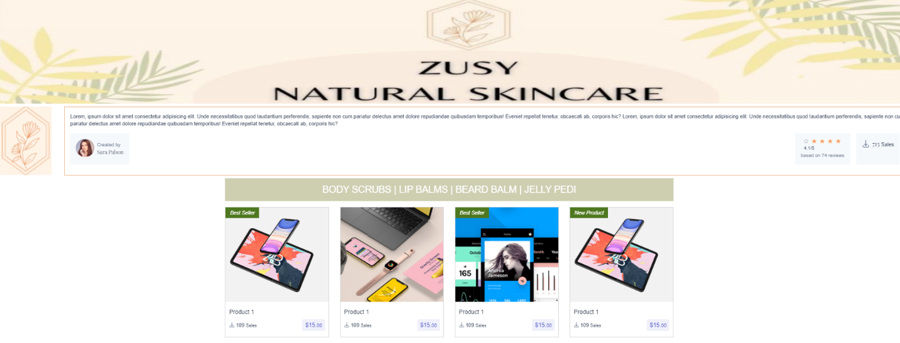

We have also realize that the way the product should be displayed is not replicated in every place there is a product, perhaps you have not reached to this just yet.

The home page is looking really good, except the information for the product again is not accurate. Reminder that EVERY product on this page should have the display information or format like the below. Which means that it includes: name of store, product rating, product description, price, number of times purchased. We are asking if the rating can be green instead of yellow.

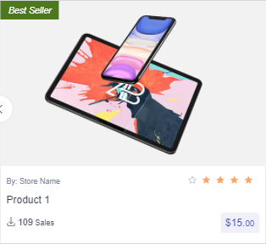

Header logo is still not as big as it should be. Also the highlight on the page that we are on is not being done automatically. It keeps having a green highlight on home, which should not be the case. wishlist and sign in icons on the header can still be a little bigger and when hover over, the font can definitely be larger. It is very important for elderly persons to be able to easily read. in the black banner above the logo, "Free Shipping over $1000" should be directly in line / in the center of the ScoutiN logo. logo needs to be alot bigger, if you look at the PDF, the logo almost lines up with the line before Be Thrifty and the line after FAQ. This means it should be much bigger.

Search bar - What are you ScoutiN for today? font should definitely be larger.

We also realized that there were some updates to the shop page. Persons should be able to click the box for Scout Supreme to filter by this. Remember for the coding job, we advised that Scout Supreme members will get different access to more promotions, and more products etc. than regular members. Sort by has been fixed AWESOME! Below generalized by, however, should be the condition of the product, whether new or used.

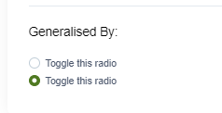

for single product review, lets be sure that there is a place where persons photos can be shown. The photos they put up of themselves wearing clothing, or the condition they receive the product in etc. ideally this would be under the rating section.

Realize we dont have a section for where the wishlist items are going just yet. We also requested if persons would like to do a registry, this should be an option that they can select what items they want and send it out to persons and once the product it sold, it becomes unavailable in the registry. There would be dif kinds of registries eg wedding, engagement, baby shower etc.

we also see updates for scout support section. The conversation icon (big green thing with words in it) should be like a thought or dialogue that the scout is saying so it needs to be alot closer to the scout, and near to his head. it is a little far apart from him here.

Vendor page looks good.

For the vendor registration page, gentle reminder that persons would need to click on the terms and agreement, and the Vendor Contract Agreements to read what it has in it, and clicking to the left of the document would be the vendor showing that they have agreed what they have read. Unless both are clicked, the vendor should not be able to move on to register.

These are the pages that we have seen with some progress thus far. We see that a number of other items are still pending. We are enthusiastic to see the rest and would keep checking in as we are so close to the end.

we also see that the footer has been amended. We are pleased to see some progress. Keep working on it and following the PDFs. ideally at the end of the week we should have all pages completed to ensure next week all functionalities requested are working as planned and agreed on.